**Rationale**

**Content Calendar**

The content calendar is designed to maintain a consistent and engaging presence on LinkedIn. By focusing on themes such as event details, success stories, and interactive content, the calendar ensures that posts remain relevant and interesting for the target audience. Posting three times a week keeps the audience engaged without overwhelming them.

**Instagram Post**

The Instagram post uses visually appealing elements and clear messaging to attract attention. The choice of Instagram allows for broader reach among young professionals and visually-oriented users. The call to action and registration link make it easy for followers to take the next step.

**Announcement Email**

The announcement email is concise and persuasive, highlighting key benefits of attending the event. It aims to motivate Braven Fellows by emphasizing networking opportunities, career growth, and the chance to learn from successful alumni and industry leaders

**1. Basic Content Calendar**

**Social Media Platform Chosen:** LinkedIn

**Timeframe:** Two months leading up to the event

**Posting Schedule:** Weekly on Mondays, Wednesdays, and Fridays

**Major Content Themes:**

1. Event Announcements and Details
2. Success Stories and Impact Highlights
3. Speaker and Partner Spotlights
4. Networking Tips and Career Advice
5. Interactive Content (Polls, Q&A, Countdown)

| **Week** | **Monday** | **Wednesday** | **Friday** |
| --- | --- | --- | --- |
| **Week 1** | Event Announcement: Save the Date | Success Story: PAF Highlight | Networking Tip: How to Prepare |
| **Week 2** | Speaker Spotlight: Keynote Announcement | Impact Highlight: Braven’s Achievements | Interactive Post: Poll on Networking Challenges |
| **Week 3** | Partner Spotlight: Featured Employer | Success Story: Employer Testimonial | Career Advice: Building a Professional Network |
| **Week 4** | Event Reminder: Registration Open | Impact Highlight: PAF Employment Stats | Interactive Post: Q&A Session Announcement |
| **Week 5** | Speaker Spotlight: Panel Discussion | Success Story: Alumni Achievements | Networking Tip: Elevator Pitch Tips |
| **Week 6** | Partner Spotlight: Donor Appreciation | Impact Highlight: Program Growth | Interactive Post: Countdown Begins (2 Weeks) |
| **Week 7** | Event Reminder: Last Call for Registration | Success Story: Personal Growth through Braven | Career Advice: Utilizing LinkedIn for Networking |
| **Week 8** | Speaker Spotlight: Final Lineup | Impact Highlight: Fellow Testimonials | Interactive Post: Final Countdown (1 Week) |

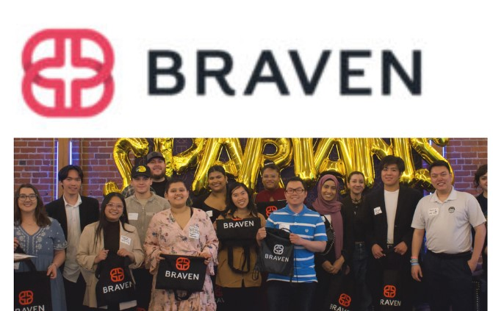

Exciting news! 🎉 The Braven Networking Event is coming up on June 25th. Don't miss this opportunity to connect with industry leaders, potential employers, and fellow Braven Post-Accelerator Fellows. Enhance your career and expand your professional network.

Register now!

https://forms.gle/t4v4v3N5AX8Jh6tV9

#BravenImpact #Networking #CareerGrowth

**Brief Announcement Email for Braven Fellows**

**Subject Line:** Join Us at the Braven Networking Event on June 25th!

**Email Body:**

Dear Braven Fellows,

We are thrilled to invite you to our upcoming Braven Networking Event, designed exclusively for you! This is a fantastic opportunity to connect with industry leaders, potential employers, and your fellow Braven Post-Accelerator Fellows.

**Event Details:**

* **Date:** June 25, 2024
* **Time:** 6:00 PM - 9:00 PM
* **Location:** [Venue Name]

Why should you attend?

* **Expand Your Network:** Meet and engage with professionals from various industries.
* **Career Opportunities:** Discover potential job openings and make valuable connections with employers.
* **Inspiration and Learning:** Hear success stories and gain insights from our distinguished speakers and alumni.

Don't miss out on this chance to take your career to the next level. Click the link below to register and secure your spot!

Register Now--https://forms.gle/t4v4v3N5AX8Jh6tV9

We look forward to seeing you there!

Warm regards,

Sania Vighneshvar Bandekar

Workforce Development & External Affairs Intern  
Workforce Development & External Affairs Team  
Braven

**Meeting Brief: Lisa Sobrato Sonsini and the Sobrato Foundation**

**Personal and Professional Background of Lisa Sobrato Sonsini**

**Education:**

* B.A., Stanford University
* J.D., UC Berkeley School of Law

**Professional Career:**

* Chair of the Board of Trustees, Sobrato Family Foundation
* Former attorney specializing in business and employment law

**Philanthropic Involvement:**

* Long-standing advocate for education, housing, and community development
* Active in various local nonprofits and initiatives focused on these areas

**Relevant Motivations:**

* Deep commitment to improving education and housing outcomes
* Interest in systemic change and long-term impact

**Motivations and Barriers to Potential Donation**

**Motivations:**

1. **Systemic Impact:** Lisa is drawn to initiatives that create lasting change and address root causes of issues.
2. **Community Development:** Strong interest in projects that benefit the local community and provide equitable opportunities.
3. **Education:** Passionate about educational programs that support underserved populations and promote upward mobility.

**Barriers:**

1. **Commitment Levels:** Potential time constraints due to existing philanthropic and professional commitments.
2. **Focused Giving:** Preference for established relationships and proven impact, which may require a strong case for Braven’s unique value proposition.

**Donation History and Interests**

**Donation History:**

* Significant contributions to education, housing, and community development initiatives in the Bay Area
* Focused on large, impactful gifts that align with the foundation’s strategic priorities

**Interests:**

* Education: Particularly K-12 and higher education support systems
* Housing: Affordable housing and homelessness prevention
* Community Development: Programs that enhance community well-being and economic stability

**Role at the Sobrato Foundation and Family**

**Role:**

* Chair of the Board of Trustees, providing strategic oversight and direction
* Key decision-maker in funding priorities and grant approvals

**Family Role:**

* Member of the prominent Sobrato family, known for their significant contributions to various philanthropic causes in the Bay Area

**Sobrato Foundation Overview**

**Foundation Overview:**

* **Mission:** To make a meaningful and measurable impact in the community through strategic philanthropy in education, housing, and community development.
* **Priority Areas:**
  + Education: Programs that support educational attainment and success for underserved populations
  + Housing: Initiatives to increase affordable housing availability and reduce homelessness
  + Community Development: Efforts to improve economic stability and well-being of local communities

**Relevant Leaders:**

* John A. Sobrato, Founder and Chair Emeritus
* Lisa Sobrato Sonsini, Chair of the Board of Trustees
* Rick Williams, CEO

**Changes Since the Pandemic and Civil Unrest:**

* Increased focus on addressing the immediate needs of vulnerable populations affected by COVID-19
* Greater emphasis on racial equity and social justice in funding decisions
* Adaptation of grantmaking processes to be more flexible and responsive to community needs

**Suggested Discussion Points for Meeting with Lisa Sobrato Sonsini**

1. **Braven's Impact and Alignment with Sobrato's Priorities:**
   * Highlight how Braven’s model supports educational success for underserved populations, aligning with the foundation’s focus on education and community development.
   * Discuss the systemic impact of Braven’s work and its potential for long-term change, resonating with Lisa’s interest in systemic impact.
2. **Success Stories and Evidence of Impact:**
   * Share compelling success stories of Braven Fellows and how the program has transformed their career trajectories.
   * Provide data and metrics that demonstrate Braven’s impact on student outcomes and employment rates.
3. **Opportunities for Collaboration and Partnership:**
   * Explore potential collaboration opportunities between Braven and the Sobrato Foundation, emphasizing shared goals and mutual benefits.
   * Discuss specific initiatives or pilot programs that could serve as a starting point for a partnership.
4. **Addressing Potential Barriers:**
   * Acknowledge Lisa’s existing commitments and discuss flexible engagement options that fit her schedule.
   * Highlight the unique value proposition of Braven in addressing current educational challenges in the Bay Area.
5. **Future Vision and Long-Term Goals:**
   * Present Braven’s vision for the future and how support from the Sobrato Foundation could accelerate achieving these goals.
   * Discuss potential long-term partnerships and strategic initiatives that align with both Braven’s and the Sobrato Foundation’s missions.

**Conclusion**

Engaging Lisa Sobrato Sonsini presents a significant opportunity to secure support from the Sobrato Foundation. By focusing on Braven’s alignment with the foundation’s priorities, showcasing compelling impact stories, and exploring flexible collaboration opportunities, the ED can effectively make a case for partnership and support.

Top of Form